**Project Design Phase**

**Solution Architecture**

|  |  |
| --- | --- |
| Date | 25 June 2025 |
| Team ID | LTVIP2025TMID30212 |
| Project Name | SmartSDLC –AI-enhanced software development lifecycle |
| Maximum Marks | 4 Marks |

**Solution Architecture:**

Solution architecture is a complex process – with many sub-processes – that bridges the gap between business problems and technology solutions. Its goals are to:

* Select the most effective AI-based technologies (IBM WatsonX, LangChain, FastAPI, Streamlit).
* Clearly define how each component supports SDLC automation.
* Document service-level interaction and user input/output behavior.
* Ensure maintainability and future extensibility (e.g., additional AI models, more SDLC tasks).

**Example - Solution Architecture Diagram:**

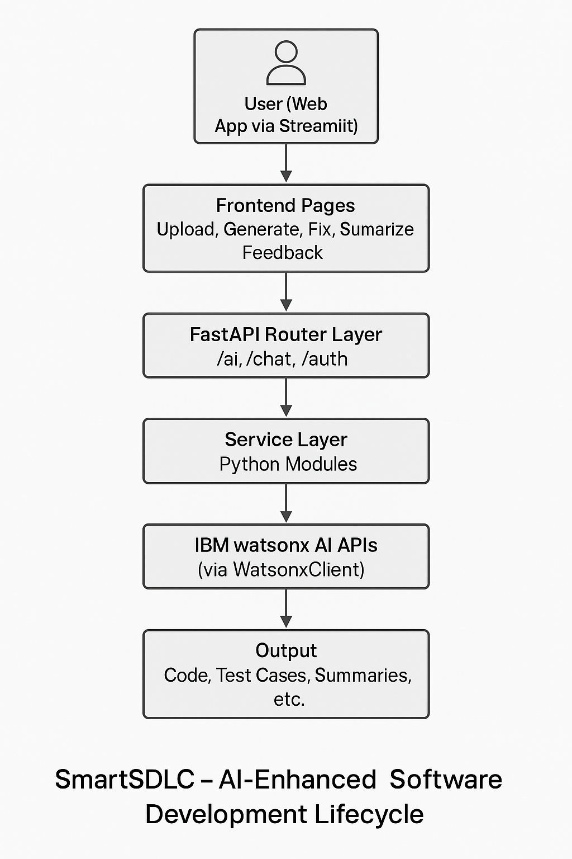

*Figure 1: Architecture and data flow of the voice patient diary sample application.*